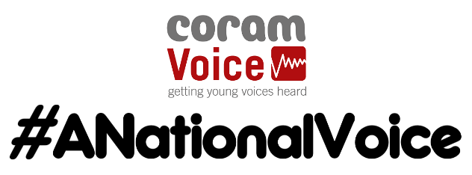
Supporting 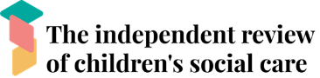
Session monitoring form – Please complete as fully as possible with the number of participants in each category.
Total Number of participants:
Where the session took place
Online | In Person

What Activities did you complete and how would you rate them out of 10
(please give a number 1-10 or N/A if you didn’t complete):
Common Ground |  | Find your pair |  | Egg Drop |  | Lego Metaphors |  | 6 words
Hot Topics |  | Design a Worker |  | What should care look like? |  | Journey of Care |  | Cliff Edges
Home is Not a Placement |  | Change 3 things |  | One word at a time |  | News Reporter |  | Low Tech Social Networking

Age of participants:
0-8yrs | 8-10 | 10-12 | 13-15 | 16-18 | 18-20 | 21+

Gender (as they identify)
Male | Female | Non-Binary | Other/Undisclosed

Ethnicity
Asian | Black | Mixed | White | Other

Long-term Disability or Health Problem that limits day to day activities (long term being over 12 months)
Yes | No

