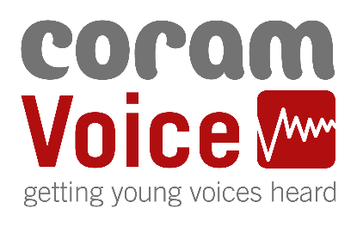
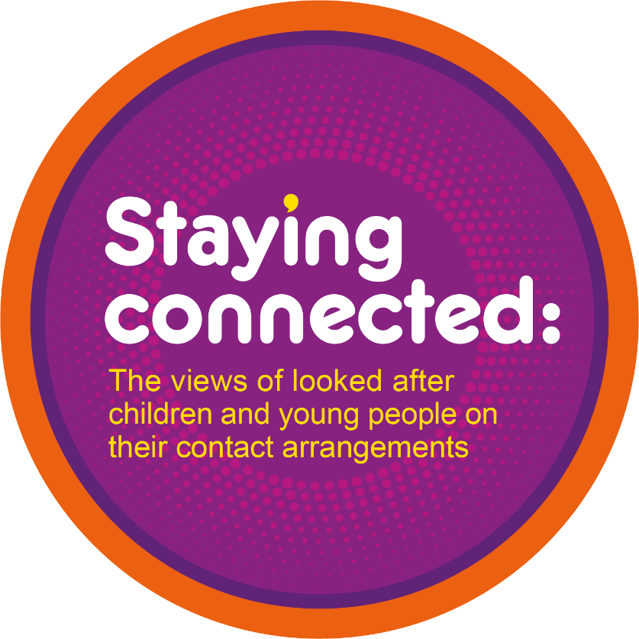
Starting conversations:
Reflecting on and reviewing services using the Bright Spots report ‘Staying Connected’

Workshop plan

2022

A note on language
In different places there are different names for supporting children to stay connected with their families. There is no perfect language. We would prefer that it did not have a name and instead conversations would focus on children keeping in touch with the people that are important to them. Labels can make young people feel different to their peers. In the Staying Connected report we have tried to use the words that children and young people used as much as possible, whilst striking a balance with presenting clear messages from the research. We would encourage the people who work with individual children to continue to ask them what works for them and use this language in their practice.

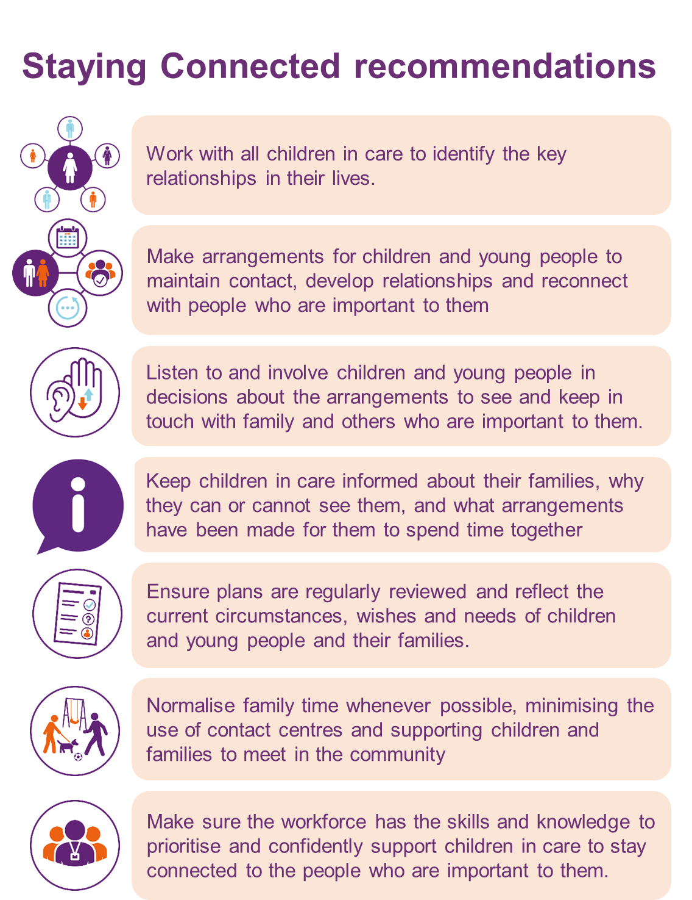
The proposed workshop plan is designed to help you as a group to reflect on the findings from the report, ‘Staying connected: The views of looked after children and young people on their contact arrangements’.
You may want to do this in a team meeting, as part of a senior management group or as specific workshop.

- Research overview (10 min)
- What? Overview of findings from the ‘Staying connected: The views of looked after children and young people on their contact arrangements’ report.
- How? Encourage staff to read the Key findings and recommendations prior to the session to familiarise themselves with the findings, then view the video of the findings together at the beginning of your session to remind yourselves of the key messages from the research. After you have seen the video, remind yourselves of the key recommendations of the report.

Local findings (optional): If you have done the Bright Spots surveys in your area – what did you learn about how your children and young people feel about time spent with the important people in their lives? Have a look at the findings in your report(s) and comments from children and young people about seeing family and other key people in their lives.

- Brainwriting (10-15 min)
- What? Brainwriting is designed to give each member of the group the chance to share their ideas at the beginning of the session. Sometimes in group sessions conversations can be dominated by more confident members of the group. By taking the time to write down ideas everyone gets the chance to share their views and this can often lead to a richer discussion.
- How? Using a series of flip charts and post it notes, or Google Jam board (https://jamboard.google.com/) or similar online tool if meeting online, ask all participants to take 10 min to explore the questions below and write down their initial thoughts about how these can be or are being addressed in your services (suggested templates for flipcharts/jamboard are included below). You may want to highlight positive things that are already happening, as well as writing down new ideas of what you think should happen.

What needs to happen to:
- Identify the people (and pets) that are important to children and young people?
- Make arrangements for children and young people to maintain contact, develop relationships and reconnect with people who are important to them?
- Make sure children and young people feel listened to and involved in decisions?
- Make sure children and young people to feel better informed about decisions and their family?
- Make sure plans are regularly reviewed and reflect the current circumstances, wishes and needs of children and young people, their families and other key people?
- Normalise family time wherever possible, minimising the use of contact centres and providing opportunities to meet in the community?
- Make sure the workforce has the skills and knowledge to confidently support family time for children in care?
Include a general page for people to comment or raise anything else.

- Discussion (Start/Stop/Stick with) (30-45 min)
  - What? Discussion of what the findings mean for your services – what you would like to bin, keep or change?
  - How? Drawing on the ideas that you have all written down in your brainwriting session, discuss what the findings mean for your services. You may want to divide into smaller groups to discuss the questions, in which case you may want to include a feedback session to the larger group. Make sure someone takes notes to capture your discussions.
    - Bin it: What should your local authority/service stop doing that would make children and young people feel happier about arrangements for family time?
    - Keep it: What is your local authority/service already doing that you should continue doing or do more of?
    - Change it: What could your local authority/service introduce or do differently?

- Next steps (10 min)
- What? Identify actions that you will take to make children and young people feel happier about staying connected with family and others who are important to them.
- How? As a group agree a set of actions based on your discussion. Identify who will take the lead on making each action happen and how and when you will review and update on progress.

Resources needed:
- Key findings and Recommendations to get a quick overview of what the research found and how services might be improved.
- Research Report for those who want to go into the findings more in depth and learn more about what children and young people reported.
- Video of findings (LINK)
- Flipcharts, pens and post its or pre-prepared Google Jamboards (https://jamboard.google.com/) or other online tool modelled on the templates below.

What needs to happen to
Identify the people (and pets) that are important to children and young people? | Make arrangements for children and young people to maintain contact, develop relationships and reconnect with people who are important to them?

What needs to happen to
Make sure children and young people feel listened to and involved in decisions? | Make sure children and young people feel better informed about decisions and their family?

What needs to happen to…
Make sure plans are regularly reviewed and reflect the current circumstances, wishes and needs of children and young people and their families and other key people. | Normalise family time wherever possible, minimising the use of contact centres and providing opportunities to meet in the community.

What needs to happen to…
Make sure the workforce has the skills and knowledge to confidently support family time for children in care? | Anything else? Any other reflections on the findings?

Bin it | Keep it | Change it
Action Plan template

Senior Leader - overall governance of action plan and monitoring arrangements:
Lead Officer - responsibility for delivery of action plan:
Reviewing arrangements - monthly, terms etc.

Service improvement area | Evidence base | Young people’s involvement | How services will improve | When | Who
Area of practice/ support to be developed | Links to Bright Spots findings and children and young people’s views | How will children & young people be involved in identifying designing, developing and monitoring | What will change?  How will you know it has changed?
1.
2.
3.
4.
5.

This workshop template was created as part of the Bright Spots Programme. The Bright Spots Programme is a partnership between Coram Voice and the University of Oxford, funded by the Hadley Trust.

For more information about the Bright Spots Programme go to:
www.coramvoice.org.uk/bright-spots
or contact:
brightspots@coramvoice.org.uk

For more information on the research contact
julie.selwyn@education.ox.ac.uk

Download other resources related to this workshop template, including the full research findings at:
www.coramvoice.org.uk/staying-connected-report

Funded by

