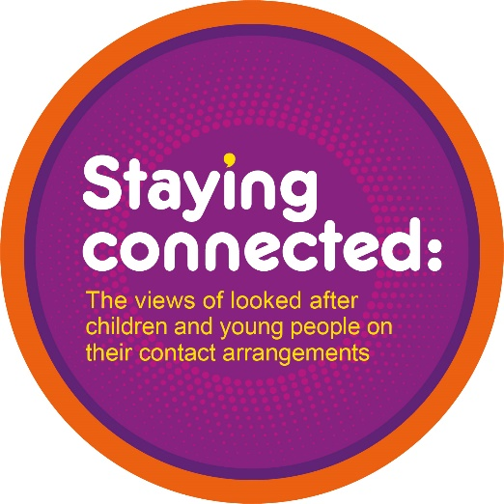

**Self-assessment and reflection sheet**

This document is part of a suite of resources created as part of the Staying Connected report – exploring the views of looked after children and young people on their contact arrangements.

Between 2015 and 2021 we had over 7,500 response to questions in the Your Life, Your Care survey about how happy children in care were with how often they saw their mum, dad, brothers and sisters. Over 3000 children and young people provided written comments.

The report and related resources can be downloaded at [www.coramvoice.org.uk/staying-connected-report](http://www.coramvoice.org.uk/staying-connected-report).

Based on the research findings and a workshop with care experienced young people, professionals and academics we identified seven key areas in which to improve policy and practice. To help services reflect on these areas, we have identified a series of questions for services to explore in order to support children and young people to spend time with the people who were important to them. These questions are not meant to be an exhaustive list but ideas to support reflection.

We would encourage you to have an ongoing dialogue in your services about the key themes and how services can best address them, including involving children and young people in identifying and implementing changes.

This document pulls out the recommendations and questions for policy and practice and gives you the chance to identify areas to explore further by ticking the questions you think are important for you service. There is also space to note reflections, ideas and actions under each recommendation.

**Completed by**

Name:

Role:

Email:

Local authority:

Date:

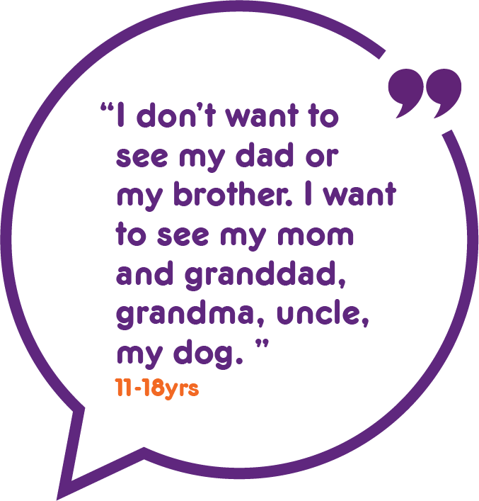**1. Work with all children in care to identify the key relationships in their lives.**

Questions for services to explore include:

► Do you work with children and young people to understand who is important to them and how and when they would like to spend time with them?

► Do your policies give the same level of priority to arranging contact with siblings as with parents?

► Do you regularly revisit plans with children and young people and check whether there are additional relationships that should be included (e.g. siblings that are born after the original plan was made, other trusted adults that are important to the child)?

► Do you audit and review whether family time/contact plans include brothers and sisters, extended family, pets and other people who are important in children’s lives (e.g. mums ex-partner, former foster carers and their children)?

► Do you use eco maps or other tools to identify key relationships and the strength of those relationships to inform children’s arrangements?

► Do you listen to and respect children’s wishes if they want contact to stop or be reduced?

|  |
| --- |
| **Notes: What more could we do in this area** |
|  |

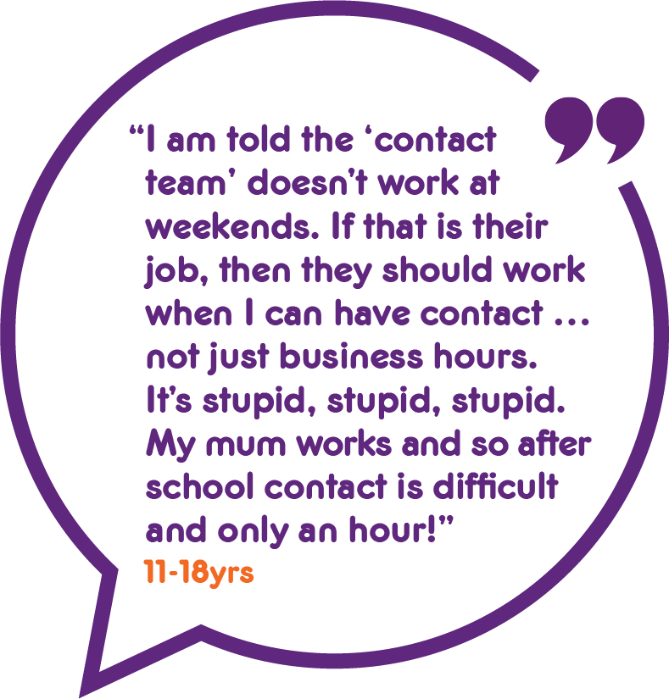**2. Make arrangements for children and young people to maintain contact, develop relationships and reconnect with people who are important to them.**

Questions for services to explore include:

► Are you enabling contact at times that work for children and families given children’s routines, work, school and other commitments (e.g. parents or siblings’ working hours, not missing after-school clubs, being mindful of meal and sleep times for younger children)?

► Are you making sure children do not worry about the costs associated with family time and is there funding available for parents, siblings’ and extended family to travel to enable contact?

► How are you supporting children and young people to re-establish relationships with people who are important to them, but they have not seen for some time?

► How can you use the time before/after a contact session to work with parents on the parent/child relationship (e.g. discussing consistent boundaries, how to play)?

► What therapeutic support are you offering to children and young people and their families to manage and improve their relationships?

► Are children in residential care experiencing additional barriers to family time and how can you support them to overcome this?

► Are independent visiting services available and offered to children and young people who have no parental contact?

► How are you supporting children to deal with loss of contact or bereavement? Is there therapeutic support available?

► How are you using contact to support young people to develop a support network that will be there for them once they have left care?

|  |
| --- |
| **Notes: What more could we do in this area** |
|  |

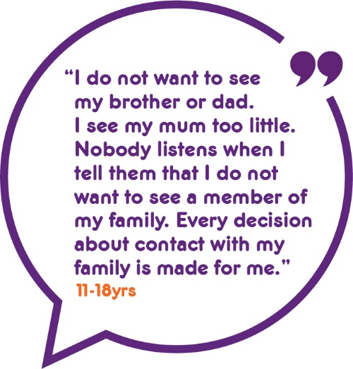**3. Listen to and involve children and young people in decisions about the arrangements to see and keep in touch with family and others who are important to them.**

Questions for services to explore include:

► Are there opportunities for children and young people to express their views about contact plans in court proceedings?

► Are children’s wishes and feelings reflected in each child’s care plan? Can processes be simplified to ensure that arrangements can be reviewed with changing circumstances?

► Do children and young people know where to turn if they are unhappy with who and how often they are seeing key people in their lives? Is support readily available and accessible to children and young people (e.g. speaking to social workers, accessing advocacy, complaints processes)?

► How are older children in care supported to manage contact with family themselves where safe for them to do so, with someone who checks in and make sure this is manageable for them?

► Do you collect data on how happy children are with family time arrangements? Does this appear in dashboard monitoring and audits?

► Are children asked to give feedback on family time services?

► Have children and young people had the opportunity to specify how they would like services to refer to family/contact time in their individual case and collectively?

|  |
| --- |
| **Notes: What more could we do in this area** |
|  |

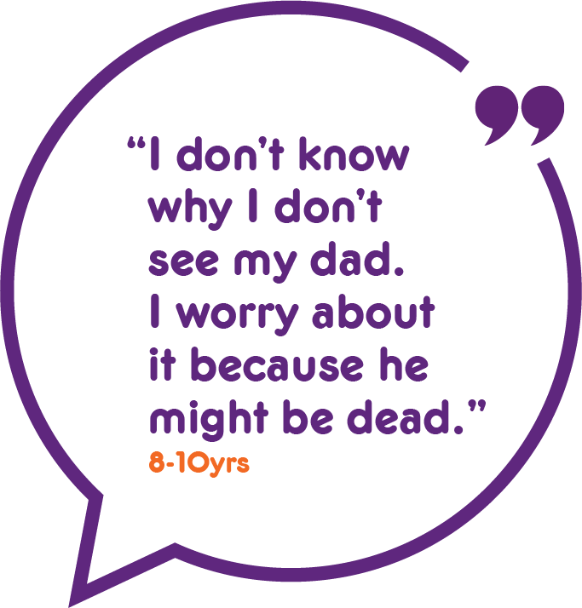**4. Keep children in care informed about their family, why they can or cannot see them and what arrangements have been made for them to keep in touch.**

Questions for services to explore include:

► Do you have child friendly communication tools to help children understand family arrangements, what will happen and when (e.g. child friendly booklets & leaflets, visual calendars, video of contact centre & what happens there)?

► Are social workers regularly taking the time to explain arrangements to children and young people and why they may be unable to see their families? Are these conversations happening with all children and young people, regardless of age?

► Are you checking whether (especially younger) children in care understand arrangements and have any unanswered questions about their families?

► How are children supported to understand who their father is and why there may be no contact? Is the extended family on the paternal side considered in planning?

► Does each child have someone who is responsible for making sure updates from family members, photographs, videos and other mementoes are shared

with the child and kept safely for them to be accessed now and in the future?

► How are carers supported to understand and explain family time arrangements to children and young people?

► If relatives do not keep to family time arrangements, do you work with them to understand why and try to remove barriers (e.g. timings, location)?

|  |
| --- |
| **Notes: What more could we do in this area** |
|  |

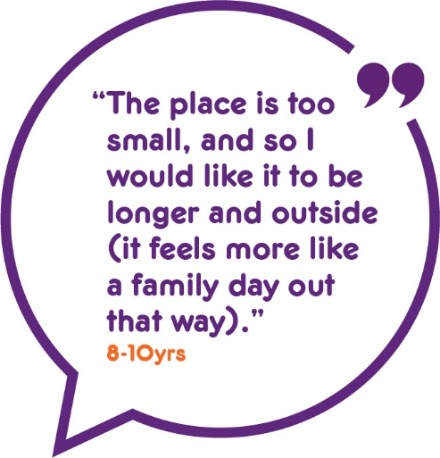**5. Normalise family time wherever possible, minimising the use of contact centres and providing opportunities to meet in the community.**

Questions for services to explore include:

► Does family time need to be supervised? If so, by who?

► Can contact staff behave in a way that gives families more privacy?

► How are risks assessed and plans to manage them developed? Do policies and procedures encourage the management of risks or avoidance of risk?

► Do families have time together which is just about spending time, i.e., not under pressure to perform or be assessed by psychologists, guardians and social workers?

► Do your contact centres provide a good range of activities for families that are suitable for all age groups (e.g. baking, playing board games, arts and crafts, outdoor play, reading)?

► Are additional activities other than face-to-face visits included in contact plans (e.g. exchanging emails, photographs, letters, phone calls, video calls)?

► What role can the child’s network take in supporting contact in the community?

► How can carers be more involved in planning and arranging contact, including online (e.g. facilitating video calls, managing email for messages)?

► How can foster carers and residential staff work together to make sure that siblings that do not live together have opportunities to spend time together?

► Can children be supported to attend family gatherings/celebrations or family members be safely invited to take part in a child’s daily activities (e.g., taking them to football practice, play groups)?

► Do you have dedicated budgets for each child in care that children, parents, carers, supervisors etc. can use to plan activities for special occasions?

|  |
| --- |
| **Notes: What more could we do in this area** |
|  |

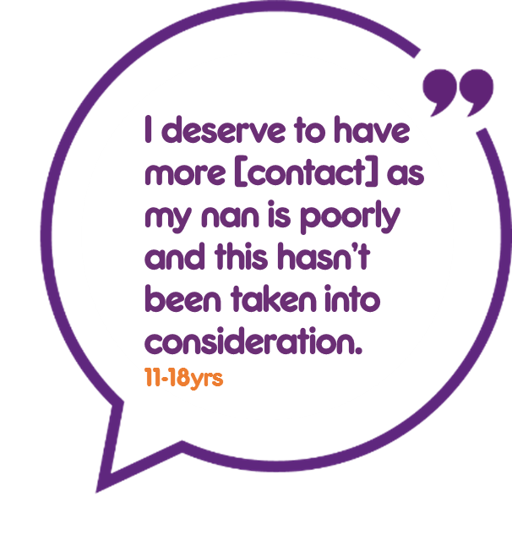**6. Ensure family time plans are regularly reviewed and reflect the current circumstances, wishes and needs of children and young people and their families**

Questions for services to explore include:

► Are plans for contact discussed in detail at the legal planning meeting (pre order), clear plans provided in the social worker’s initial statement and in the Care Plan, ensuring that plans are in the best interests of the child?

► Do IROs proactively review children and young people’s contact plans every 6 months, making sure that they are up-to-date, have considered the current views of the child or young person about increasing, reducing or ending contact and taken account of changes in family circumstances?

► How do you work with carers and schools to observe and explore how children and young people feel before and after contact, picking up on worries and engaging them in discussions about this?

► If a family member has died, what arrangements have been made for children to be supported to visit the grave and whether visits should be repeated on key dates?

► Can contact arrangements be changed quickly if there is a sudden change in circumstances (e.g. if a grandparent becomes ill)?

|  |
| --- |
| **Notes: What more could we do in this area** |
|  |

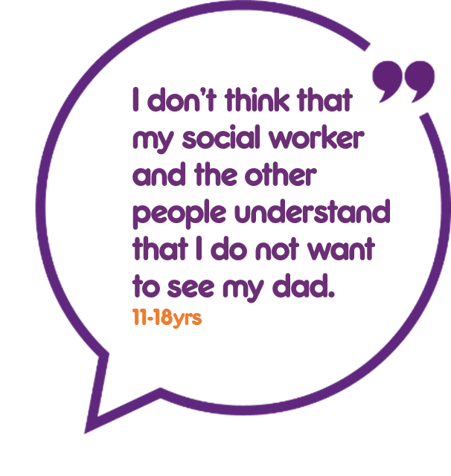**7. Make sure the workforce has the skills and knowledge to confidently support family time for children in care.**

Questions for services to explore include:

► Does everyone who works with children in care recognise their role in supporting family contact (social workers, IROs, foster and residential carers etc.) and are aware of their duties under existing guidance and regulations?

► Have you embedded regular review of contact plans and a focus on wishes and feelings through supervision, audits and training (e.g. practice week focus)?

► Are workers trained in how to use different tools to understand children’s wishes and feelings and who is important to them (e.g. eco maps, genograms)

► Do social workers feel confident in talking to children about why they cannot live with their families, why there might be limitations and helping children to manage any disappointment or feelings of rejection when contact does not go as planned?

► Do workers and carers feel confident in supporting family time for Unaccompanied Asylum Seeking Children whose families may be abroad and may not be contactable in the same ways as other children? What training and development can you offer to upskill them in this domain?

► Do workers have the skills and knowledge to talk to children and young people

about their worries?

► Do workers have the skills and knowledge to support families to develop better relationships, as part of family time?

► Do you need to commission any specialist services to support children and families (e.g. therapeutic or bereavement services, family counselling or conflict management)?

► Do workers consider how birth, step, foster or adoptive parents might be worked with to make sure children keep in touch with their brothers and sisters?

|  |
| --- |
| **Notes: What more could we do in this area** |
|  |