Appendix A



<https://creazilla.com/media/clipart/7817642/tree>

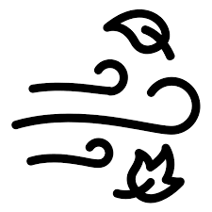

<https://commons.wikimedia.org/wiki/File:Wind_%2880439%29_-_The_Noun_Project.svg>



<https://creazilla.com/media/clipart/3172519/mountain>

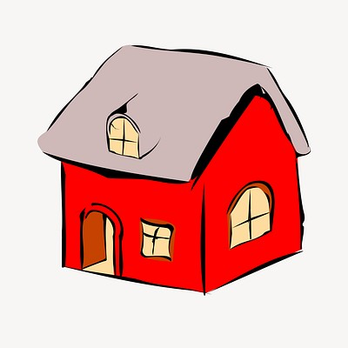

<https://www.rawpixel.com/image/6579385/vector-christmas-sticker-public-domain>

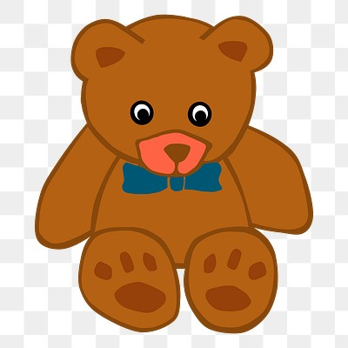

<https://www.rawpixel.com/image/6340828/vector-sticker-public-domain-illustrations>



<https://creazilla.com/media/clipart/59831/football-ball>



<https://www.rawpixel.com/image/7580142/vector-paper-book-illustrations>



<https://creazilla.com/media/emoji/44768/puzzle-piece>



<https://creazilla.com/media/emoji/48040/key>

Appendix B

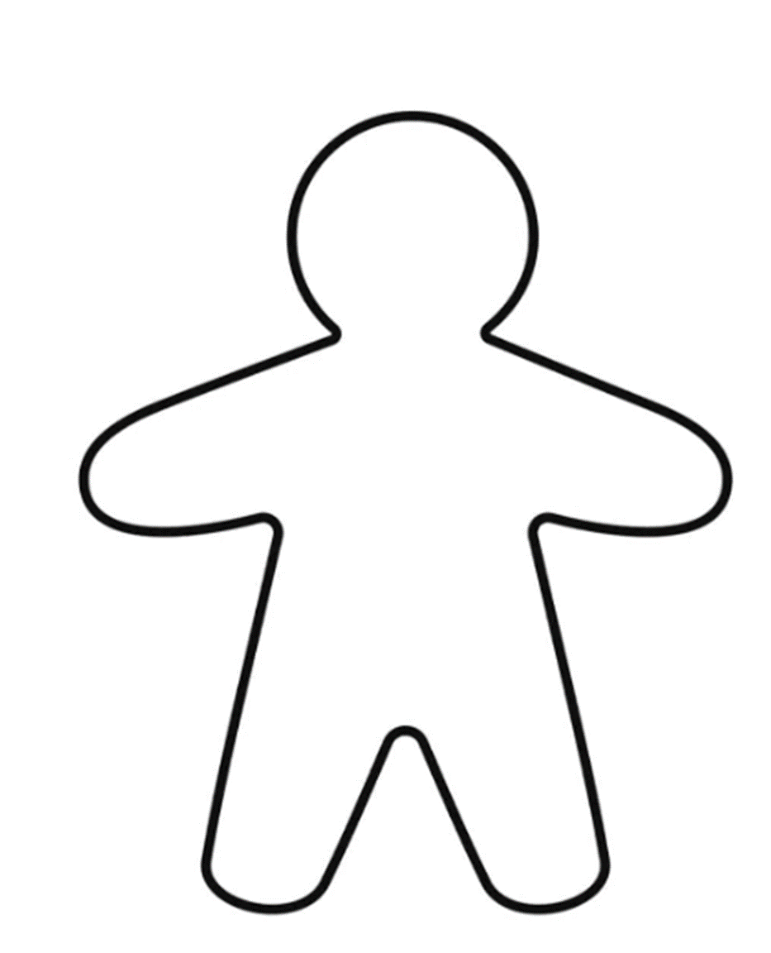

Appendix C

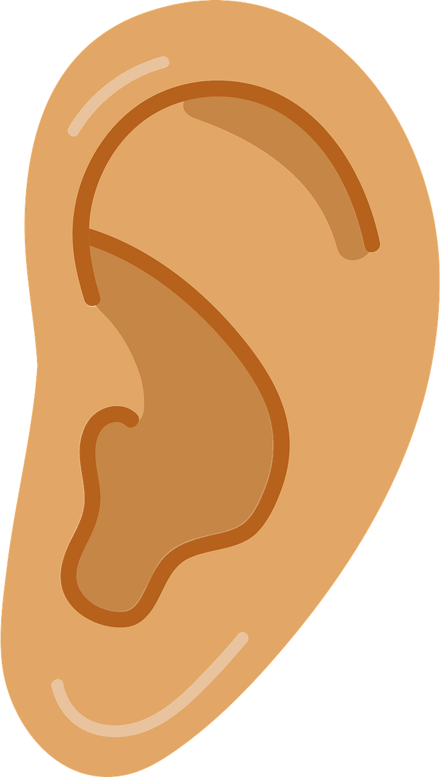

Listening <https://creazilla.com/media/clipart/76469/ear>

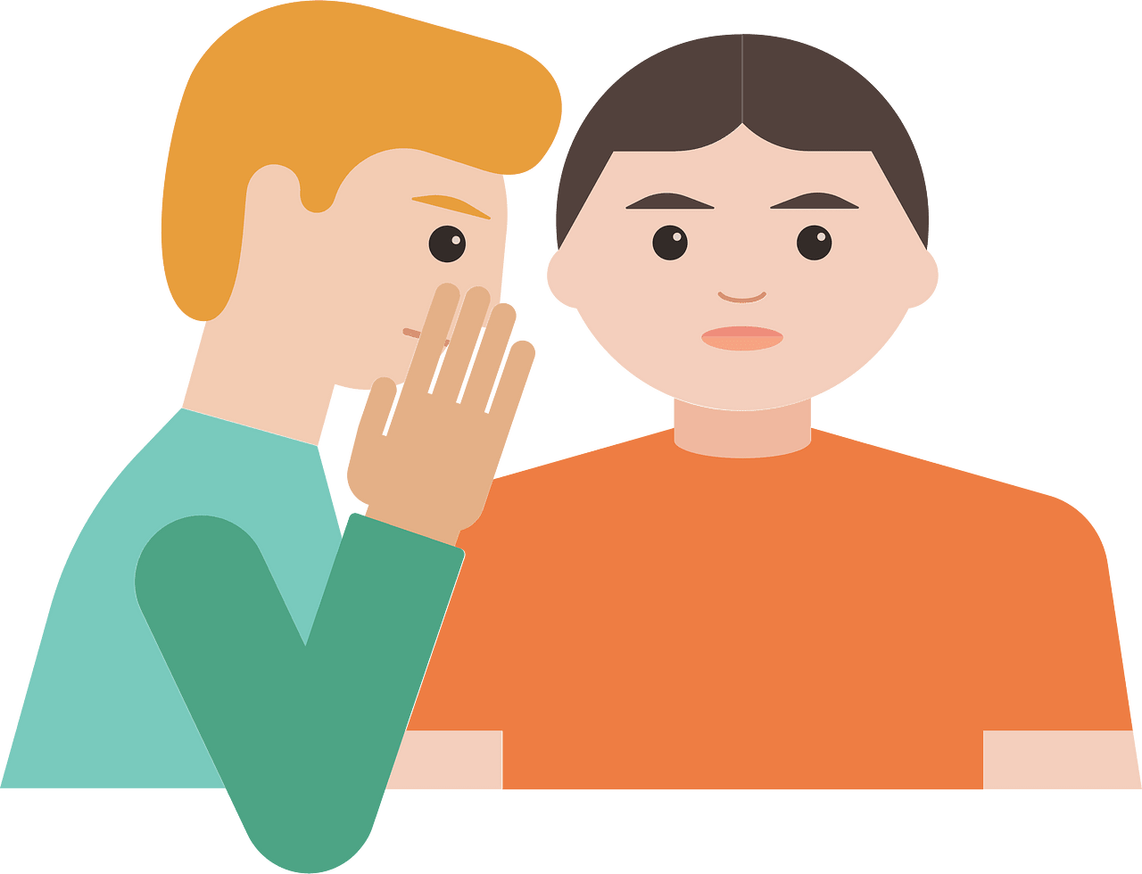

Telling secrets <https://creazilla.com/media/clipart/7874766/telling-secret>

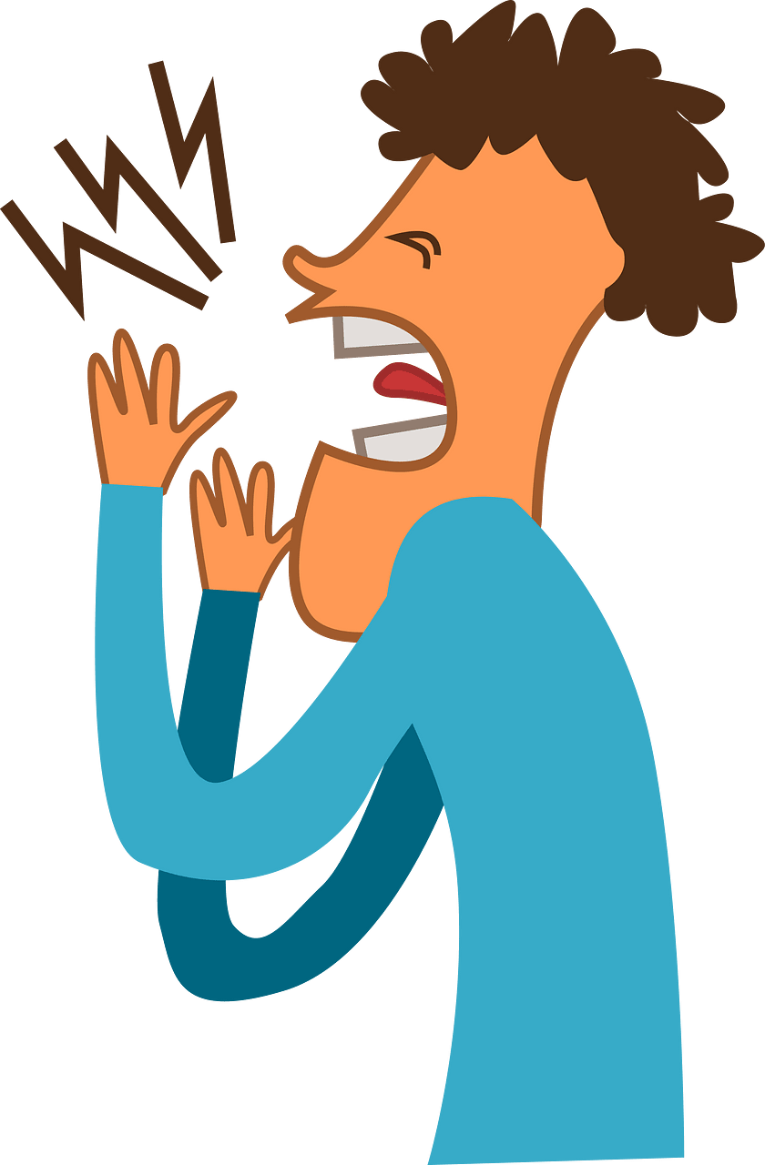

Shouting <https://creazilla.com/media/clipart/3152710/man-shouting>

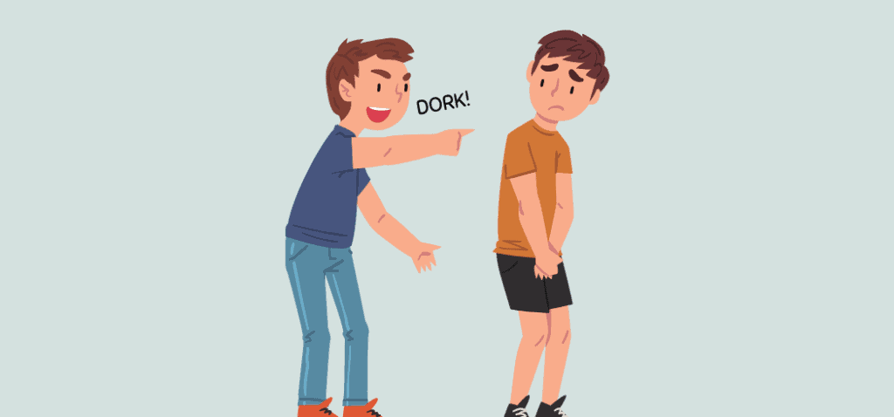

Calling names <https://grammarist.com/idiom/name-calling/>



Saying sorry <https://creazilla.com/media/clipart/7769983/cat-is-praying>

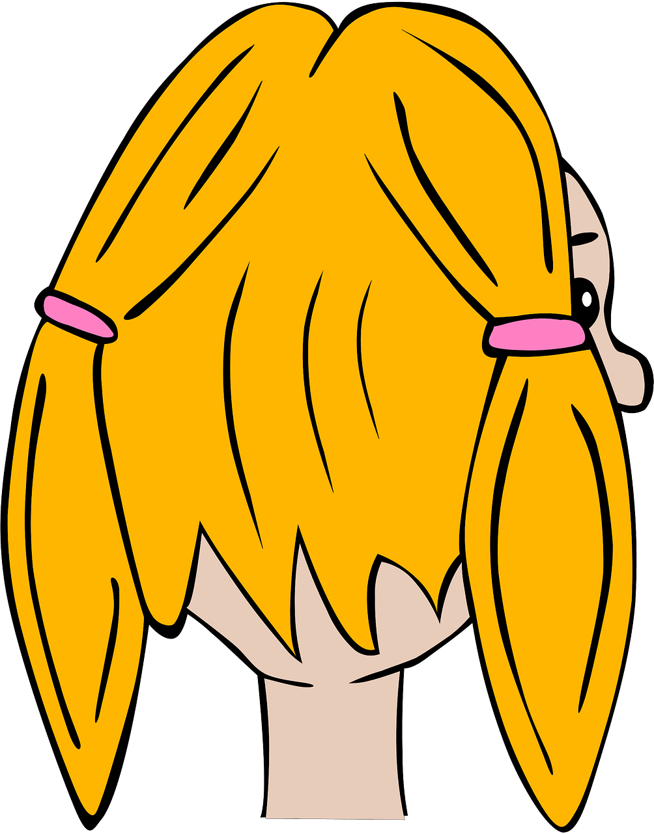

Ignoring <https://creazilla.com/media/clipart/3175455/girl>



Lying <https://creazilla.com/media/icon/7907203/emoji-u1f91e-1f3fe>

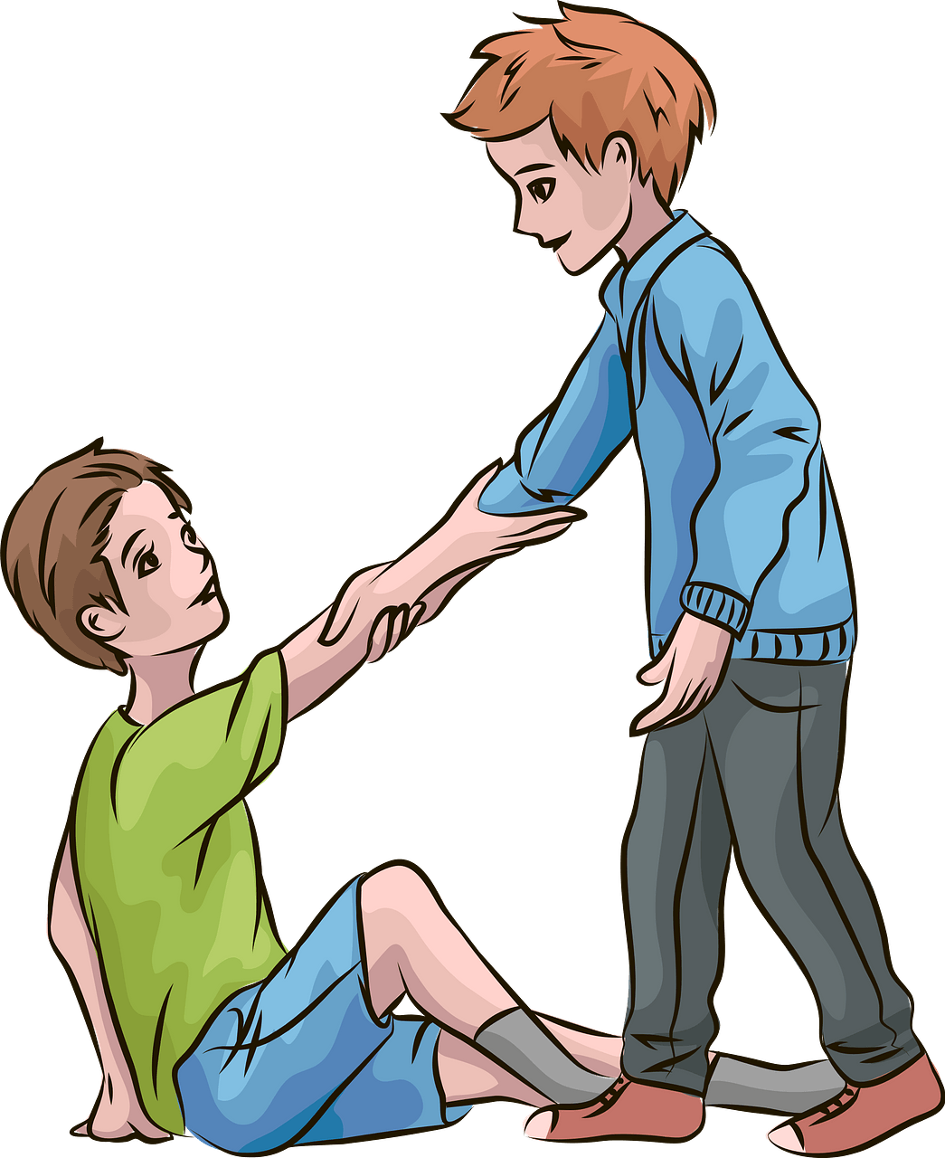

Asking for help <https://creazilla.com/media/clipart/70248/boy-helping-other-boy-to-stand-up>

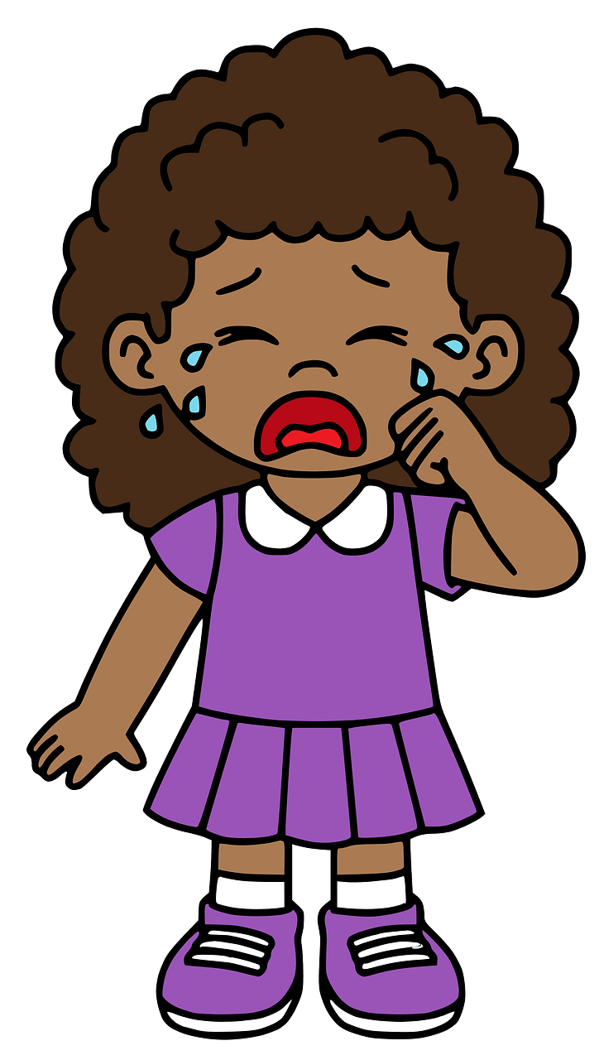

Telling when you are sad <https://creazilla.com/media/clipart/7795532/crying-girl>

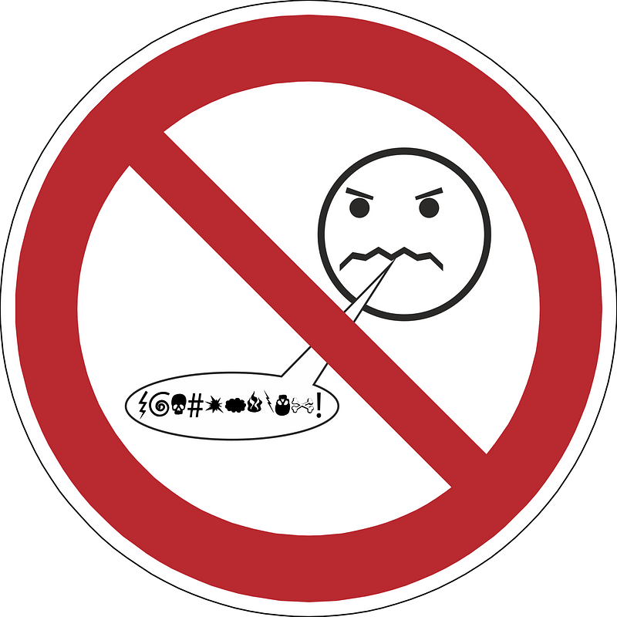

Swear words <https://creazilla.com/media/icon/3432144/shield>